Definition:

In this project, it is the goal of the team to develop an accurate and reliable means to estimate the walking velocity and slope of incline wholly from a single IMU mounted on the subjects’ leg.

Initial test was conducted on 05-03, however all means so far were unable to determine a means to estimate accurate velocity and slope from the recorded accelerations and slopes. The current hypothesis is that since the data was recorded with the IMU positioned on the subject’s femur, the recorded accelerations were too weak to be properly recorded either through quantization noise or perhaps low SNR.

This test will position the IMU in several locations and use the resulting data to determine the best position of the IMU to get the most accurate velocity estimates. The primary locations will be (in order of significance) proximal lateral shank, proximal lateral femur, atop the foot (“in the shoelaces”), and at the base of the spine (above the sacrum). Femur and Shank collection locations are detailed in Addendums I & II.

If time permits, the next level of significance will be to collect data from distal locations on both the shank and femur. This will provide insight into the dependence of the data collection with IMU position.

If time permits, an additional outcome of this collection may be to have a short test of the existing WISE algorithm in a real-time setting. This may provide some initial views of the performance of the un-optimized code. NOTE: The existing code has been developed using (1) a difference IMU collecting at a slower sampling rate and different sensors and (2) data collections which very well may be “non-bankable” (i.e. unusable). Therefore, results cannot be anticipated to be valid.

Test Objectives:

There are several objectives is this test:

1. To determine the optimal position on the subject which yields the most reliable IMU data.   
   There is an open question about the effect of IMU position on the recoded data. Most papers seem to prefer to place the IMU on the shank. For our previous test, we collected mid-thigh. For this test, it would be desirable to get data collections from several locations. This could include (in order of desirability) shank, thigh, foot, trunk.  
   For future reference, it may be useful to take pictures of the IMU on each subject before each test (perhaps with some sort of measurement reference as well). This variable depends on what mounting mechanisms are available for the test.
2. To collect 6 axis IMU data at several levels of incline and speed which will be used to better develop the estimation algorithms.  
   This will be to replicate the previous collection. At a minimum, we would like the same levels of incline [-3%, 0%, 3%, 15%] as well as the same speeds [1.8 mph, 2.2 mph, 2.7 mph]. Additional speeds/inclines would be very useful, however only applicable if time permits.
3. To test the WISE algorithm at several speeds/slopes using the existing algorithms to determine the ability of the existing algorithms to estimate speed/slope.  
   This will only be a short collection of tests. We would like to run the WISE algorithm (no raw collection of IMU data, only estimation outputs) to get a rough but real-time idea of the performance of the algorithms. If time permits, we may test several combinations of speed/slope and log the results.

For this test, it is very desirable to have at least a few different subjects to get a decent variance in the data. In the previous collection 4 subjects were available. This, again, depends on the availability of time and the access to different subjects.

For each run, data will be collection for at least 2 min (120 seconds).

**Subject Name:**

|  |  |  |  |  |
| --- | --- | --- | --- | --- |
| **No.** | **IMU Position** | **Speed (MPH)** | **Incline (%)** | **Time of Collection** |
| 1 | Foot | 1.8 | -3 |  |
| 2 | Foot | 2.2 | -3 |  |
| 3 | Foot | 2.7 | -3 |  |
| 4 | Foot | 1.8 | 0 |  |
| 5 | Foot | 2.2 | 0 |  |
| 6 | Foot | 2.7 | 0 |  |
| 7 | Foot | 1.8 | 3 |  |
| 8 | Foot | 2.2 | 3 |  |
| 9 | Foot | 2.7 | 3 |  |
| 10 | Foot | 1.8 | 15 |  |
| 11 | Foot | 2.2 | 15 |  |
| 12 | Foot | 2.7 | 15 |  |
| 13 | Shank | 1.8 | -3 |  |
| 14 | Shank | 2.2 | -3 |  |
| 15 | Shank | 2.7 | -3 |  |
| 16 | Shank | 1.8 | 0 |  |
| 17 | Shank | 2.2 | 0 |  |
| 18 | Shank | 2.7 | 0 |  |
| 19 | Shank | 1.8 | 3 |  |
| 20 | Shank | 2.2 | 3 |  |
| 21 | Shank | 2.7 | 3 |  |
| 22 | Shank | 1.8 | 15 |  |
| 23 | Shank | 2.2 | 15 |  |
| 24 | Shank | 2.7 | 15 |  |
| 25 | Femur | 1.8 | -3 |  |
| 26 | Femur | 2.2 | -3 |  |
| 27 | Femur | 2.7 | -3 |  |
| 28 | Femur | 1.8 | 0 |  |
| 29 | Femur | 2.2 | 0 |  |
| 30 | Femur | 2.7 | 0 |  |
| 31 | Femur | 1.8 | 3 |  |
| 32 | Femur | 2.2 | 3 |  |
| 33 | Femur | 2.7 | 3 |  |
| 34 | Femur | 1.8 | 15 |  |
| 35 | Femur | 2.2 | 15 |  |
| 36 | Femur | 2.7 | 15 |  |
| 37 | Trunk | 1.8 | -3 |  |
| 38 | Trunk | 2.2 | -3 |  |
| 39 | Trunk | 2.7 | -3 |  |
| 40 | Trunk | 1.8 | 0 |  |
| 41 | Trunk | 2.2 | 0 |  |
| 42 | Trunk | 2.7 | 0 |  |
| 43 | Trunk | 1.8 | 3 |  |
| 44 | Trunk | 2.2 | 3 |  |
| 45 | Trunk | 2.7 | 3 |  |
| 46 | Trunk | 1.8 | 15 |  |
| 47 | Trunk | 2.2 | 15 |  |
| 48 | Trunk | 2.7 | 15 |  |

**Subject Name:**

|  |  |  |  |  |
| --- | --- | --- | --- | --- |
| **No.** | **IMU Position** | **Speed (MPH)** | **Incline (%)** | **Time of Collection** |
| 1 | Shank |  |  |  |
| 2 | Shank |  |  |  |
| 3 | Shank |  |  |  |
| 4 | Shank |  |  |  |
| 5 | Shank |  |  |  |
| 6 | Shank |  |  |  |
| 7 | Shank |  |  |  |
| 8 | Shank |  |  |  |
| 9 | Shank |  |  |  |
| 10 | Shank |  |  |  |
| 11 | Shank |  |  |  |
| 12 | Shank |  |  |  |
| 13 | Shank |  |  |  |
| 14 | Shank |  |  |  |
| 15 | Shank |  |  |  |
| 16 | Shank |  |  |  |
| 17 | Shank |  |  |  |
| 18 | Shank |  |  |  |
| 19 | Shank |  |  |  |
| 20 | Shank |  |  |  |
| 21 | Shank |  |  |  |
| 22 | Shank |  |  |  |
| 23 | Shank |  |  |  |
| 24 | Shank |  |  |  |
| 25 | Femur |  |  |  |
| 26 | Femur |  |  |  |
| 27 | Femur |  |  |  |
| 28 | Femur |  |  |  |
| 29 | Femur |  |  |  |
| 30 | Femur |  |  |  |
| 31 | Femur |  |  |  |
| 32 | Femur |  |  |  |
| 33 | Femur |  |  |  |
| 34 | Femur |  |  |  |
| 35 | Femur |  |  |  |
| 36 | Femur |  |  |  |
| 37 | Femur |  |  |  |
| 38 | Femur |  |  |  |
| 39 | Femur |  |  |  |
| 40 | Femur |  |  |  |
| 41 | Femur |  |  |  |
| 42 | Femur |  |  |  |
| 43 | Femur |  |  |  |
| 44 | Femur |  |  |  |
| 45 | Femur |  |  |  |
| 46 | Femur |  |  |  |
| 47 | Femur |  |  |  |
| 48 | Femur |  |  |  |

**Subject Name:**

|  |  |  |  |  |  |
| --- | --- | --- | --- | --- | --- |
| **No.** | **IMU Position** | **Speed** | **Incline** | **Ave. Speed est.** | **Ave. Incline Est.** |
| 1 |  |  |  |  |  |
| 2 |  |  |  |  |  |
| 3 |  |  |  |  |  |
| 4 |  |  |  |  |  |
| 5 |  |  |  |  |  |
| 6 |  |  |  |  |  |
| 7 |  |  |  |  |  |
| 8 |  |  |  |  |  |
| 9 |  |  |  |  |  |
| 10 |  |  |  |  |  |
| 11 |  |  |  |  |  |
| 12 |  |  |  |  |  |
| 13 |  |  |  |  |  |
| 14 |  |  |  |  |  |
| 15 |  |  |  |  |  |
| 16 |  |  |  |  |  |
| 17 |  |  |  |  |  |
| 18 |  |  |  |  |  |
| 19 |  |  |  |  |  |
| 20 |  |  |  |  |  |
| 21 |  |  |  |  |  |
| 22 |  |  |  |  |  |
| 23 |  |  |  |  |  |
| 24 |  |  |  |  |  |
| 25 |  |  |  |  |  |
| 26 |  |  |  |  |  |
| 27 |  |  |  |  |  |
| 28 |  |  |  |  |  |
| 29 |  |  |  |  |  |
| 30 |  |  |  |  |  |
| 31 |  |  |  |  |  |
| 32 |  |  |  |  |  |
| 33 |  |  |  |  |  |
| 34 |  |  |  |  |  |
| 35 |  |  |  |  |  |
| 36 |  |  |  |  |  |
| 37 |  |  |  |  |  |
| 38 |  |  |  |  |  |
| 39 |  |  |  |  |  |
| 40 |  |  |  |  |  |
| 41 |  |  |  |  |  |
| 42 |  |  |  |  |  |
| 43 |  |  |  |  |  |
| 44 |  |  |  |  |  |
| 45 |  |  |  |  |  |
| 46 |  |  |  |  |  |
| 47 |  |  |  |  |  |
| 48 |  |  |  |  |  |

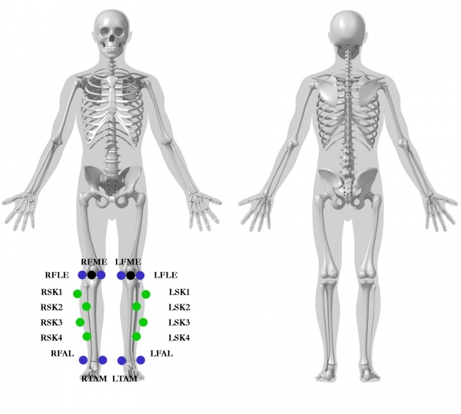**Addendum I: Shank Collection Locations**

Primary collection location will be the proximal lateral of the subject’s shank (RSK3).

Subsequent collections (for determining location dependence of collection) will be placed distal, either towards RFLE/LFLE (Femur Lateral Epicondyle) or towards RFAL/LFAL (Fibula Apex of Lateral Malleolus) noted in the figure (right).

Locations should be noted in the collection table using the positions detailed in the figure (right).

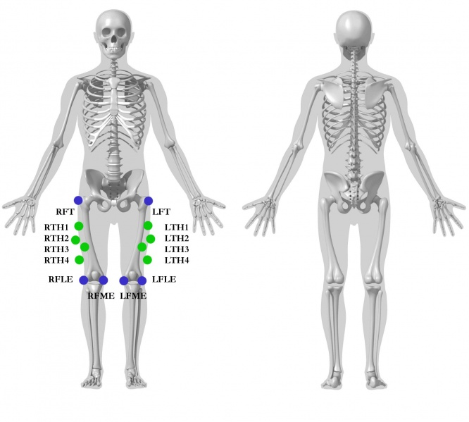**Addendum II: Femur Collection Locations**

Primary collection location will be the proximal lateral of the subject’s femur (RTH2).

Subsequent collections (for determining location dependence of collection) will be placed distal, either towards RFT/RFT (Femur greater Trochanter) or towards RFLE/LFLE (Femur Lateral Epicondyle) noted in the figure (right).

Locations should be noted in the collection table using the positions detailed in the figure (right).